Perform Incremental Import operation to load data from Mysql To HDFS using Sqoop.

//CREATING A DB IN MYSQL

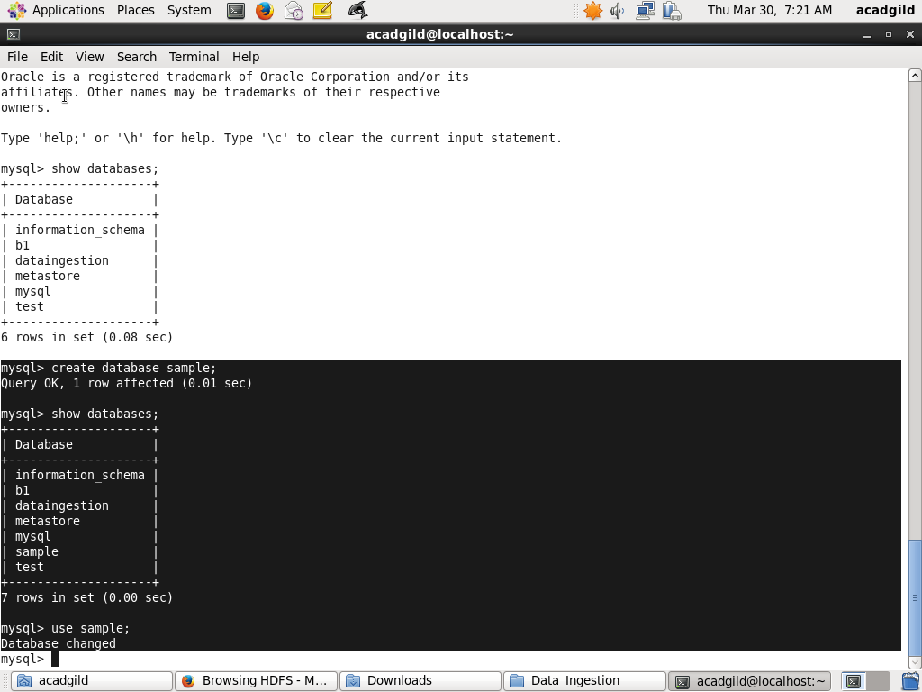

//CREATING THE TABLE EMP

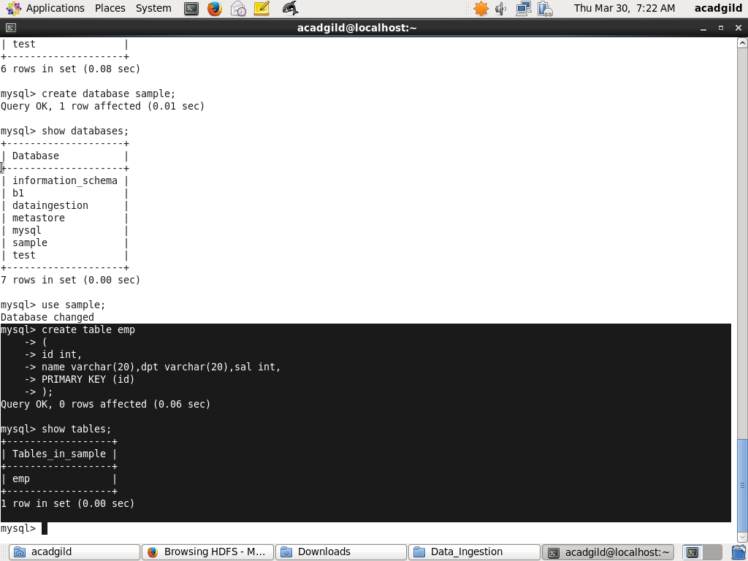

//INSERTING 10 VALUES

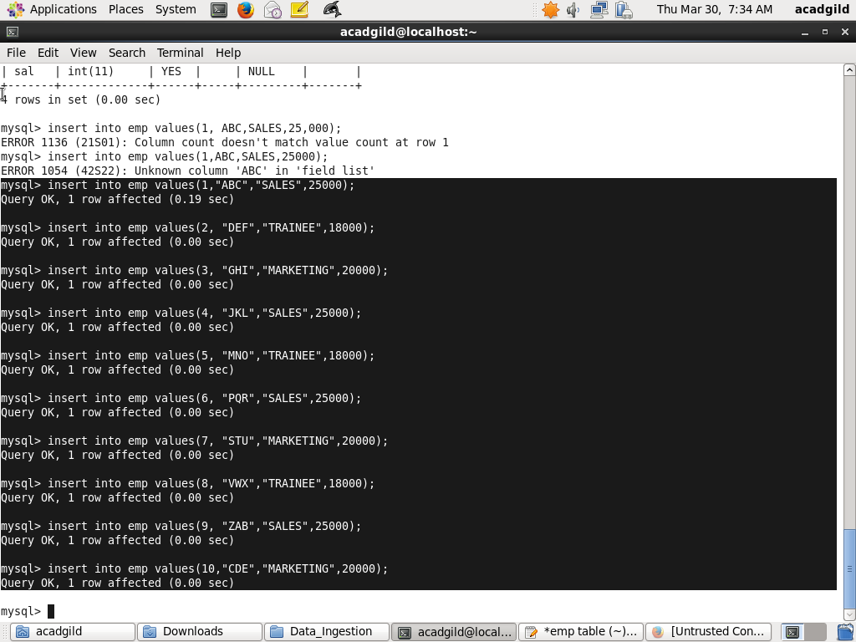

//DATA IN EMP

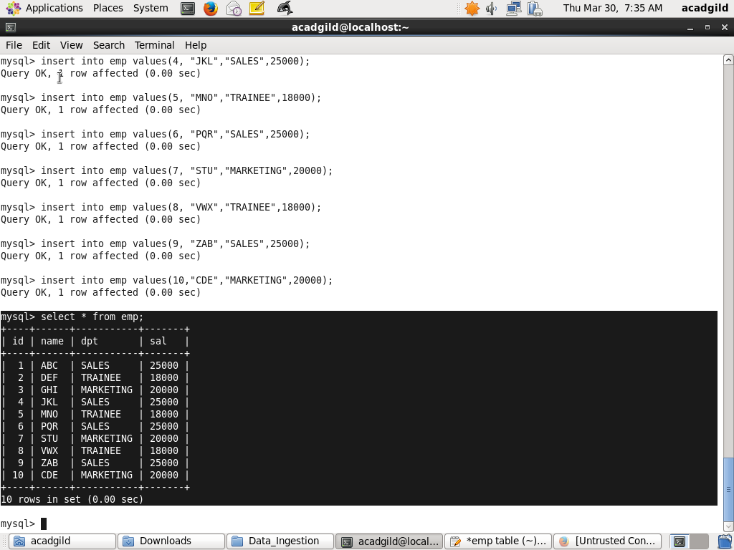

//SQOOP INCREMENTAL APPEND

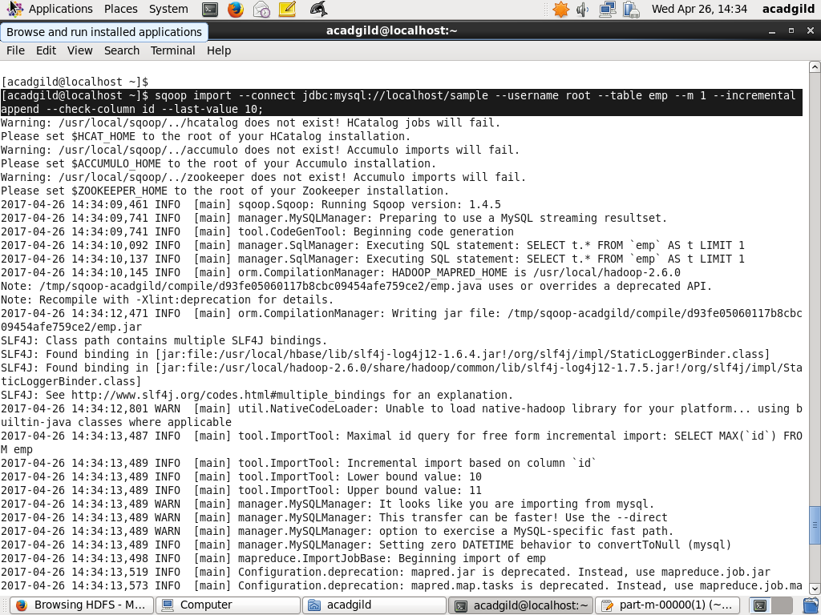

//RESULT IN HDFS

